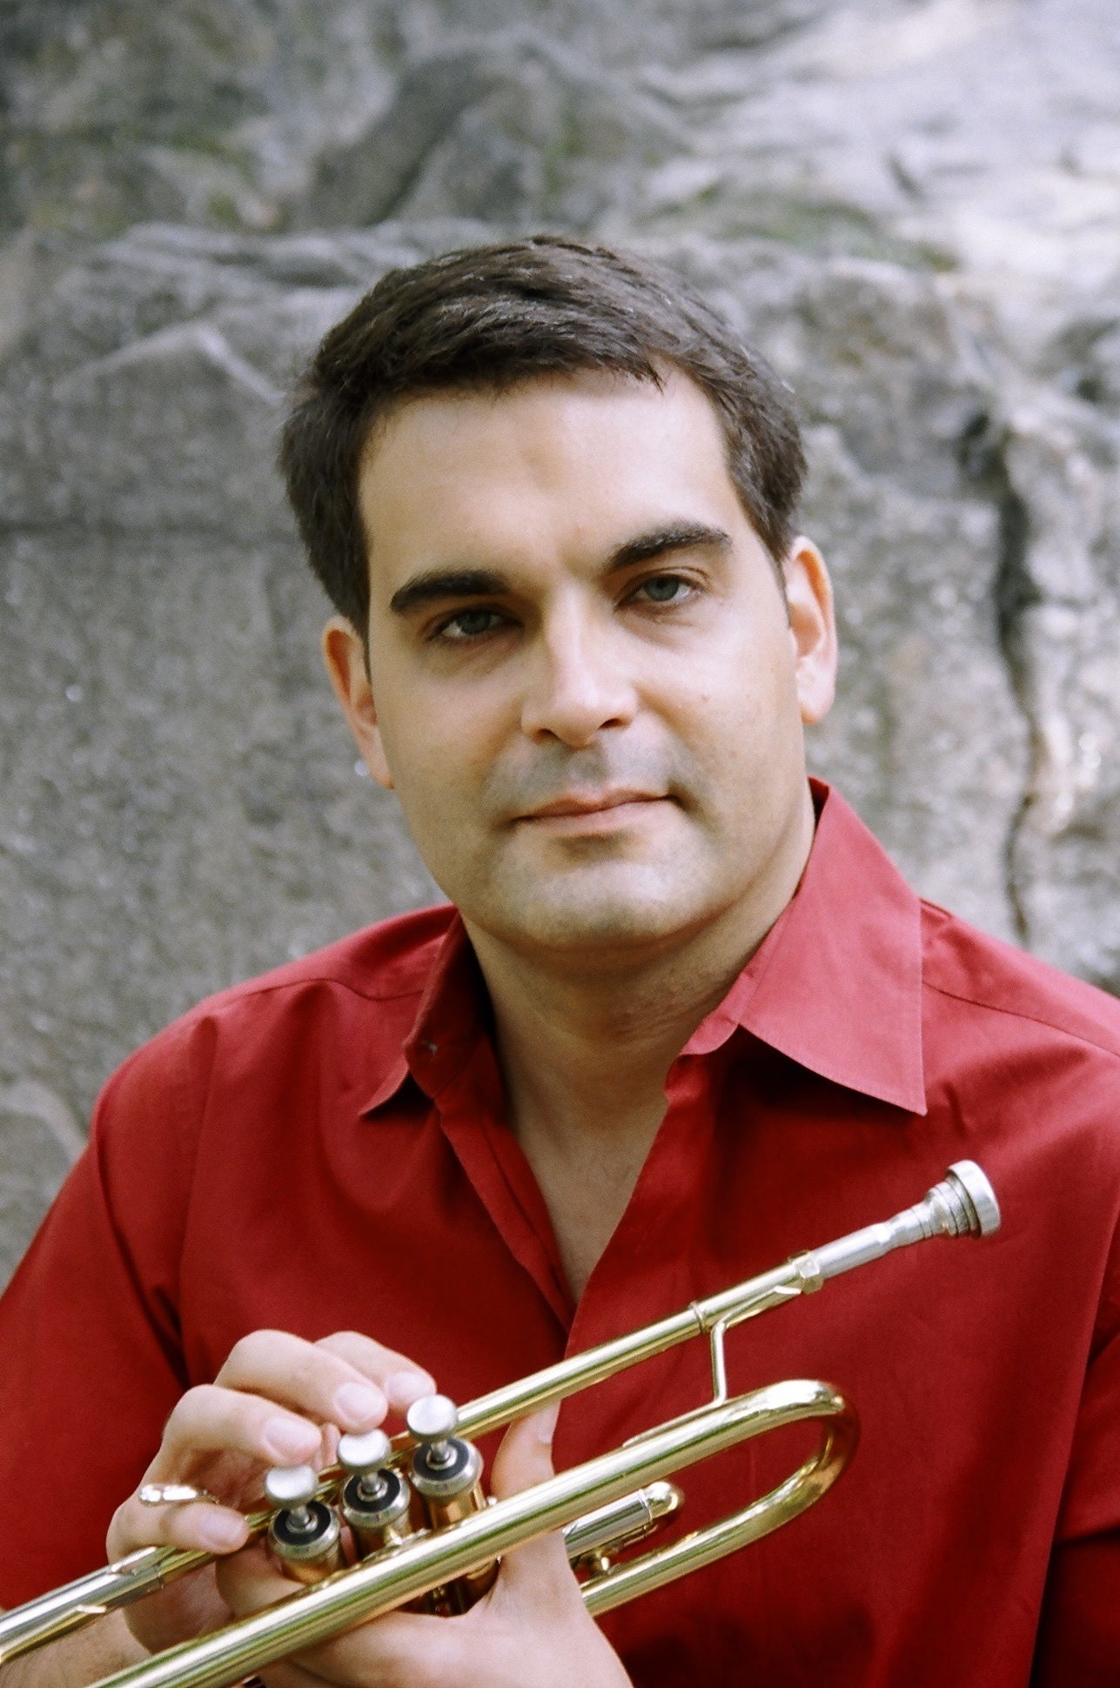
Trumpet Lessons
By Jon Menges

I am a full-time musician and experienced music teacher living in the New York City area. I currently substitute teach in the music departments at the Dalton School and Hunter High School. I also have been teaching private trumpet students for 10 years. I am strongly committed to finding the most effective methods for teaching each individual student.

All Levels
Lessons in your home or online
Trumpet Basics

With every student, I work on the basics in small, manageable goals.

- Correct embouchure
- Breathing
- Sight reading
- Music theory
- Fundamentals of jazz and classical trumpet
- Jazz improvisation

Teaching Methods

I incorporate the basics into lessons that build confidence and fun.

- Writing a song
- Choosing music the student enjoys
- Adjusting each lesson to the individual
- Designing exercises for fun and learning

I was trained in music at Northwestern and Indiana Universities. I’ve played trumpet in many contexts from big bands to jazz groups to classical ensembles. I am also an active jazz composer and arranger. I live in New York City.

Telephone: 917-674-1859
Email: jon@mengesmusic.com

